Shashank Umar Vaishy

Roll Number-B23CS019

Branch-Computer Science and Engineering

FOR-CS-255 lab

|  |  |  |
| --- | --- | --- |
| S. no. | Objective// | Date |
| 1 | Creating portfolio using HTML | 14/8/24 |
| 2 | Creating table using HTML | 21/8/24 |
| 3 | Creating a Student Registration HTML form | 28/8/24 |
| 4 | Linking multiple Webpages together | 4/9/24 |
| 5 | Apply CSS Box Model over the same. Implementing CSS IDs, classes and CSS Styling over the lists and tables. | 11/9/24 |
| 6 | Design question paper of ten questions of yourself using CSS styling | 11/9/24 |
|  |  |  |
|  |  |  |
|  |  |  |
|  |  |  |
|  |  |  |
|  |  |  |
|  |  |  |
|  |  |  |
|  |  |  |
|  |  |  |

INDEX

Create your own portfolio using HTML. Using the mentioned tags in the page is must.  
Within the body use the following tags:

* Moving text " Welcome to my portfolio"
* Different heading tags (H1-H6).
* Paragraph, Horizontal line, Line Break
* Pre tag <pre>
* Different Logical Style (<b>,<sub>,<sup>,...)
* Different Physical style (<strike>,<del>)
* Listing tags
* Special tags
* Attributes, metadata
* Web page Icon

Code for objective ‘1’ i.e.”Portfolio using HTML”

<!DOCTYPE html>

<html lang="en">

<head>

    <meta charset="UTF-8">

    <meta name="viewport" content="width=device-width, initial-scale=1.0">

    <meta name="description" content="Shashank's Portfolio">

    <title>Shashank's Portfolio</title>

    <link rel="icon" href="pi.png">

    <style>

        *{

            margin:2px;

        }

        body{

            padding: 0;

            margin: 0;

            background-color:#E3B5A4;

            border: 3px solid rgb(8, 8, 8);

        }

        #moving{

            font-weight: 1000;

            color:#0B0014;

            font-size:xx-large;

            background-color: rgb(246, 227, 199);

        }

        .intro{

        }

        .contact{

            padding: 3px;

            background-color: #773344;

            color:#F5E9E2 ;

        }

        .headings{

            border: 3px solid black;

            background-color: #773344;

            color:#F5E9E2 ;

            /* border: 3px solid #F5E9E2; */

            justify-content: center;

            text-align: center;

        }

        .code{

            border: 2px dashed black;

            text-align: justify;

            color: black;

            background-color: rgb(221, 215, 180);

        }

    </style>

</head>

<body>

    <marquee id="moving" >

        <img src="namaste.png" style="height:50px;">Welcome to my Portfolio <img src="namaste.png" style="height:50px;"></marquee>

    <div class="headings">

        <img src="nitlogo-removebg-preview.png" alt=""> <h1><u>Shashank </u></h1>

    <p>BTech,Computer Science and Engineering<br>Sophomore @ NIT Meghalaya <br>E-Mail-b23cs019@nitm.ac.in</p></div>

    <br>

    <div class="headings"><h2>-About Me- <br></h2></div>

    <div class="intro"><p style="text-align: center;">Hello! I am <b>Shashank Umar Vaishy</b>, a 3<sup>rd</sup> semester BTech student in Computer Science and Engineering at NIT Meghalaya. I have a passion for coding and problem-solving, with skills in Java, C, and Data Structures and Algorithms.I'm also working on my development skills by practicing HTML, CSS and JavaScript.</p></div>

    <div class="headings" style="margin-top: 2rem;"><h3>My Skills</h3></div>

    <ul>

        <li>Java</li>

        <li>C</li>

        <li>Data Structures & Algorithms</li>

        <li>JavaScript</li>

        <li>CSS</li>

        <li>HTML 5</li>

    </ul>

    <div class="headings" style="margin-top: 2rem;"><h4>Experience</h4></div>

    <p>No professional experience yet. Eager to gain hands-on experience through internships and projects.</p>

    <div class="headings"style="margin-top: 2rem;"><h4>My Projects</h4></div>

    <ol >

        <li><p><b>Tic-Tac-Toe</b></p>

        </li>

        <li><p><b>Rock Paper Scissors</b></p>

           </li>

           <li><p><b><strike>N/A</strike></b></p></li>

    </ol>

    <div class="headings" style="margin-top: 2rem;"><h4>My Education</h4></div>

    <ul>

        <li><p><b>National Institute of Technology Meghalaya</b> <i>Bachelor of Technology</i> - Computer Science & Engineering (2023 - Present)</p></li>

        <li><p><b>Y.M. Convent School</b>

        <i>Class XI & XII-</i> PCM</p></li>

        <li><p><b>Bright English School</b>

            <i>Class IX & X-</i> Advanced MAthematics</p></li>

            <li><p><b>Cambridge Academy School</b>

                <i>Nursery to class VIII</i> </p></li>

    </ul>

    <br>

    <div class="headings" style="margin-top: 2rem;"><h3>Simple Java Code</h3>

    <div class="code"><pre>class PortFolio {

        public static void main(String[] args) {

            System.out.println("Hii! Welcome to my page :)");

        }

    }

</pre></div></div>

<div class="contact" style="margin-top: 2rem;">

    <div class="headings"><h3>Contact</h3></div>

    <div class="contacts">

        <a href="" style="color: rgb(238, 225, 207);">Instagram</a>,

        <a href="" style="color: rgb(238, 225, 207);">LinkedIn</a>,

        <a href="" style="color: rgb(238, 225, 207);">Facebook</a>,

        <button style="background-color: #773344; color: rgb(238, 225, 207);"><a href="mailto:umarshashank@gmail.com">Mail Me!</a></button>,

        <a href="" style="color: rgb(238, 225, 207);">My GitHub</a>

    </div>

</div>

    <br>

    <marquee id="moving" >

        Thanks For Visiting </marquee>

</body>

</html>

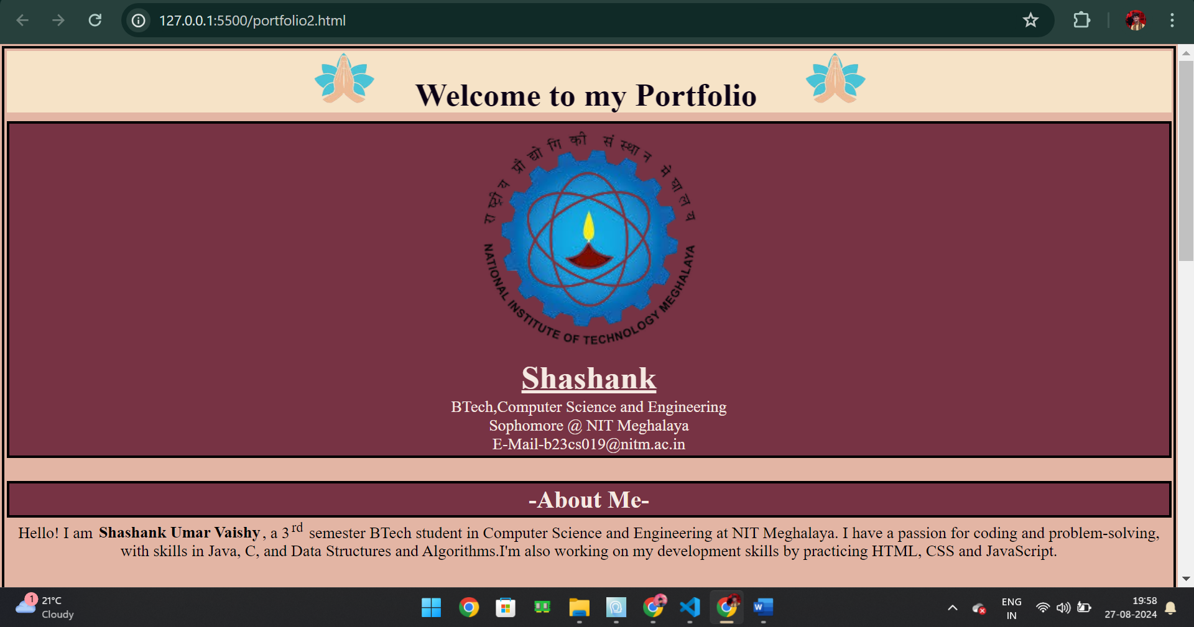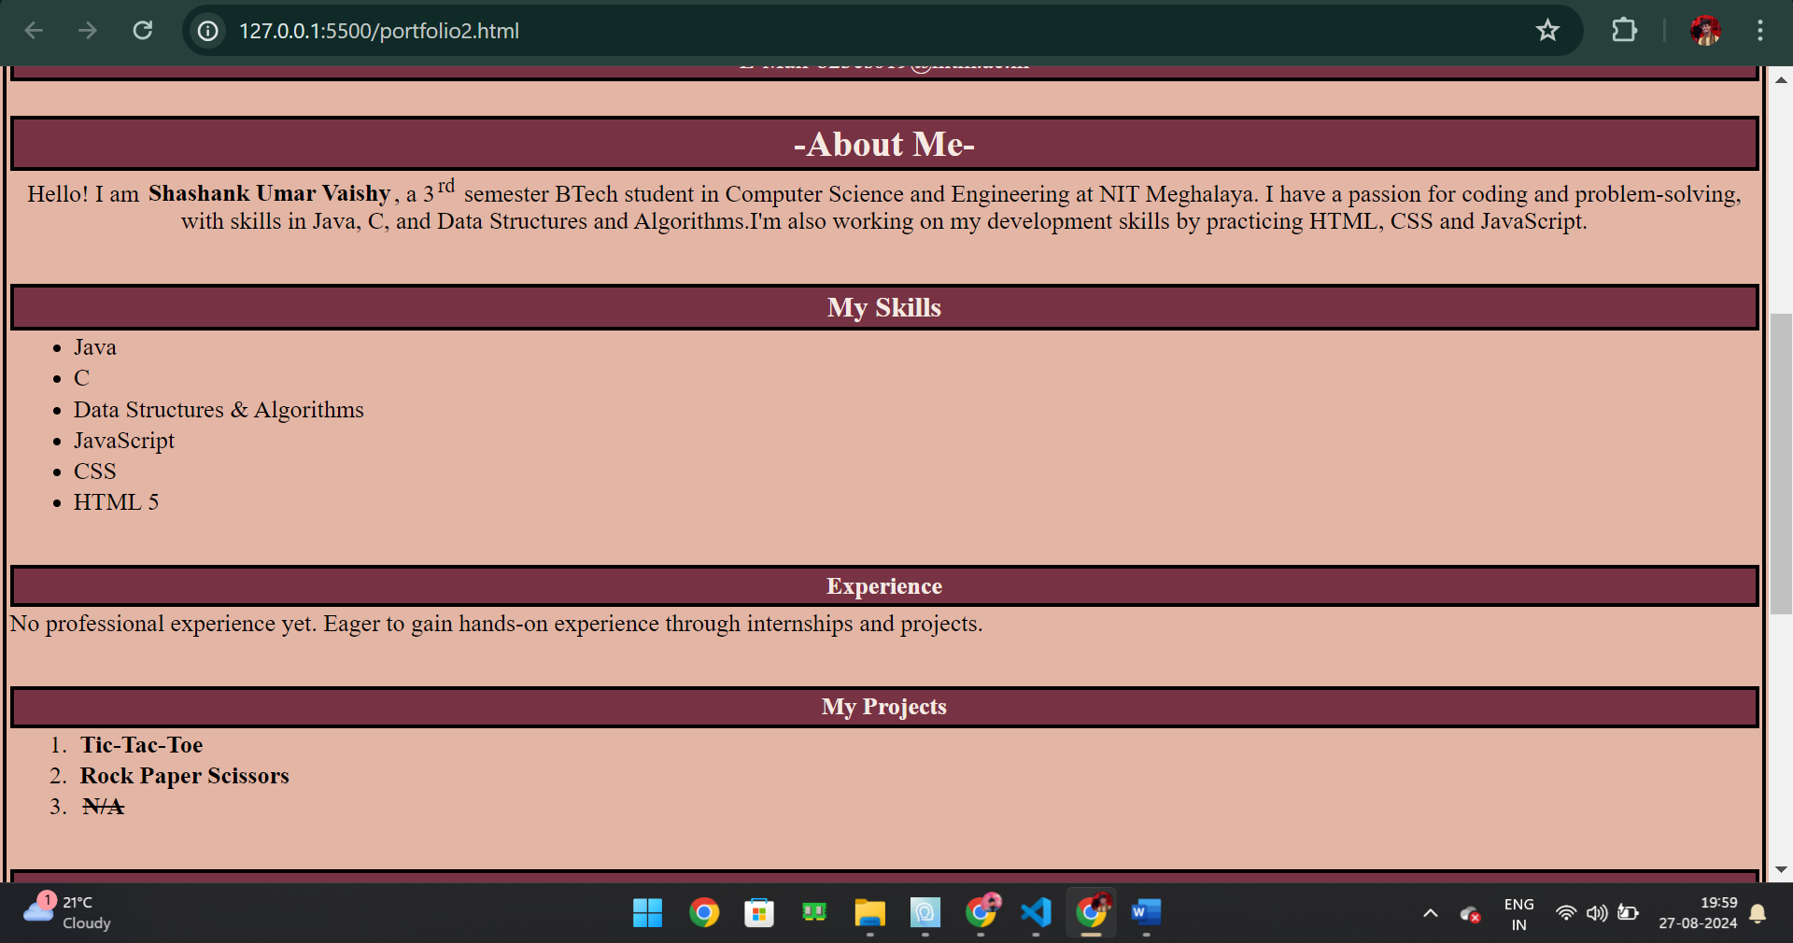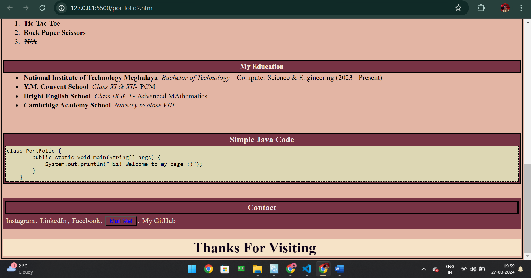

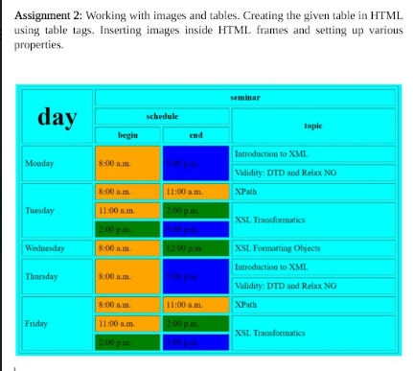

Code for objective ‘2’ i.e.”Table using HTML”

<html>

<head>

    <meta charset="UTF-8">

    <meta name="viewport" content="width=device-width, initial-scale=1.0">

    <link rel=stylesheet href="stylesheet.css"></link>

    <title>Time-Table</title>

      <style>

        body{

            margin: 0;

            padding: 0;

            background-image: url(creative-education-background-with-school-supplies-vector.jpg);

            display: flex;

            flex-direction: column;

            align-items:center;

        }

        #heading{

            padding-left: 5rem;

            padding-right: 5rem;

            display: flex;

            align-items: center;

            justify-content: center;

            margin: 2rem;

            font-family:'Segoe UI', Tahoma, Geneva, Verdana, sans-serif ;

            font-weight: 900;

            border: 4px solid #000000;

            border-radius: 3rem;

            box-shadow: 3px 3px 3px rgba(255, 255, 255, 0.2);

        }

        tr{

            border: 1px solid black;

        }

        td{

            padding-left: 3rem;

            padding-right: 3rem;

            padding-top: 0.5rem;

            padding-right: 0.5rem;

            text-align: center;

        }

        th{

            background-color: rgba( 255, 255,255,0.2);

            border: 2px solid black;

            color: white;

        }

        table{

            font-size: large;

            border:2px solid black;

            margin-bottom: 2rem;

            border-collapse: collapse;

            background-color: rgba( 0, 0,0,0.2);

            box-shadow: 3px 3px 3px rgba(255, 255, 255, 0.4);

        }

        td:hover, .topic:hover{

             background-image: linear-gradient(to bottom, #6c6eda  , #e5aa70);

           color: black;

        }

      </style>

</head>

<body>

        <div id="heading">

        <h1>Time-Table</h1>

    </div>

    <div id="table">

    <table>

        <tr>

            <th rowspan="3" id="day">Day</th>

            <th colspan="3" class="seminar">Seminar</th>

        </tr>

        <tr>

            <th colspan="2" id="schedule">Schedule</th>

            <th rowspan="2" id="topic">Topic</th>

        </tr>

        <tr>

            <th id="time">Begin</th>

            <th id="end">End</th>

        </tr>

        <tr>

            <td rowspan = "2"class="day">Monday</td>

            <td class="time">8:00 a.m.</td>

            <td class="end">5:00 p.m.</td>

            <td class="topic">Introduction to XML</td>

        </tr>

        <tr>

            <td class="time">8:00 a.m.</td>

            <td class="end">5:00 p.m.</td>

            <td class="topic">Validity: DTD and Relax NG</td>

        </tr>

        <tr>

            <td rowspan = "3"class="day">Tuesday</td>

            <td class="time">8:00 a.m.</td>

            <td class="end">11:00 a.m.</td>

            <td class="topic">XPath</td>

        </tr>

        <tr>

            <td class="time">11:00 a.m.</td>

            <td class="end">2:00 p.m.</td>

            <td class="topic">XSL Transformations</td>

        </tr>

        <tr>

            <td class="time">2:00 p.m.</td>

            <td class="end">5:00 p.m.</td>

            <td class="topic">XSL Transformations</td>

        </tr>

        <tr>

            <td class="day">Wednesday</td>

            <td class="time">8:00 a.m.</td>

            <td class="end">12:00 p.m.</td>

            <td class="topic">XSL Formatting Objects</td>

        </tr>

        <tr>

            <td rowspan = "2" class="day">Thursday</td>

            <td class="time">8:00 a.m.</td>

            <td class="end">5:00 p.m.</td>

            <td class="topic">Introduction to XML</td>

        </tr>

        <tr>

            <td class="time">8:00 a.m.</td>

            <td class="end">5:00 p.m.</td>

            <td class="topic">Validity: DTD and Relax NG</td>

        </tr>

        <tr>

            <td rowspan ="3"class="day">Friday</td>

            <td class="time">8:00 a.m.</td>

            <td class="end">11:00 a.m.</td>

            <td class="topic">XPath</td>

        </tr>

        <tr>

            <td class="time">11:00 a.m.</td>

            <td class="end">2:00 p.m.</td>

            <td class="topic">XSL Transformations</td>

        </tr>

        <tr>

            <td class="time">2:00 p.m.</td>

            <td class="end">5:00 p.m.</td>

            <td class="topic">XSL Transformations</td>

        </tr>

    </table>

    </div>

</body>

</html>

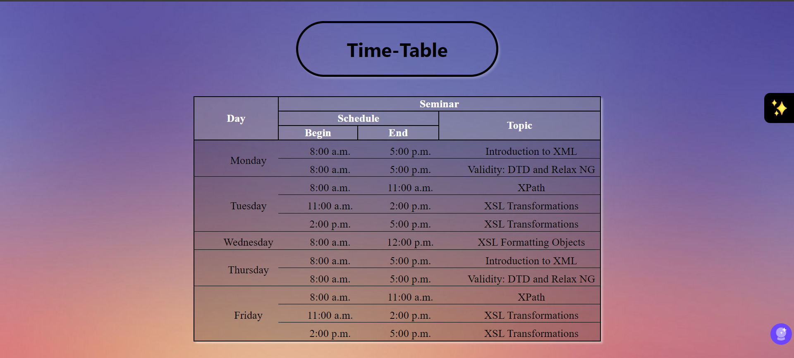

Assignment 3: Creating a Student Registration HTML form. The details asked should be:  
First-Name, Last-Name, Email ID, Mobile Number, Address, Hobbies, Course, Gender,  
Date-of-Birth, etc.

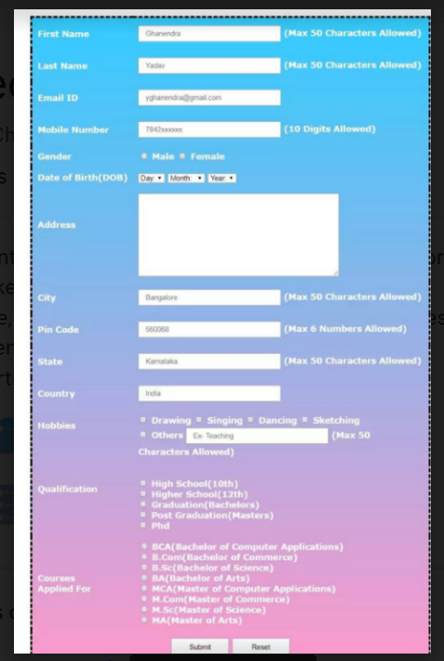

Code for objective 3 -

<!DOCTYPE html>

<html lang="en">

<head>

    <meta charset="UTF-8">

    <meta name="viewport" content="width=device-width, initial-scale=1.0">

    <title>Student Registration Form</title>

    <style>

        body {

            padding:0;

            margin: 0;;

            font-family:cursive;

            background: linear-gradient(to bottom, #ee8888, #e1b6a4);

        }

        .form-container {

            display: flex;

            justify-content: center;

            background-color: rgba(255, 255, 255, 0.225);

            border-radius: 1rem;

            border:1px solid white;

            box-shadow: 5px 10px 18px rgba(255, 255, 255, 0.25);

        }

        td{

            margin-right:1 rem;

        }

        #max{

            font-style: italic;

            color: rgba(0, 0, 0, 0.5);

        }

        table{

            width: 96vw;

            height: 100vh;

        }

        .form-container input[type="text"],

        .form-container input[type="email"],

        .form-container input[type="number"],

        .form-container textarea

        {

            width: 95%;

            border-radius: 5px;

            border:1px solid white;

            box-shadow: 5px 10px 18px rgba(255, 255, 255, 0.3);

            background-color: rgba(255, 255, 255, 0.3);

        }

        .form-container input[type="radio"],

        .form-container input[type="checkbox"] {

            margin-right: 5px;

        }

        .form-container select{

            border-radius: 5px;

            border:1px solid white;

            box-shadow: 5px 10px 18px rgba(255, 255, 255, 0.3);

            background-color: rgba(255, 255, 255, 0.3);

        }

        .form-container button {

            padding: 10px 15px;

            margin: .5rem;

            background-color: #333;

            color: white;

            box-shadow: 5px 10px 18px rgba(255, 255, 255, 0.3);

            border: 1px solid white;

            border-radius: 5px;

            cursor: pointer;

        }

        .form-container button:hover {

            background-color: #555;

        }

        #container{

            display: flex;

            justify-content: center;

            padding-bottom: 9px;

        }

        .otherHobby{

            display: inline-block;

        }

        tr,td{

            padding : 8px;

        }

    </style>

</head>

<body>

    <div class="form-container">

        <form>

            <table>

                <tr><th colspan="3"><h2 id="heading">Student Registration Form</h2></th>

                </tr>

                <tr>

                    <td>First Name:</td>

                    <td><input type="text" name="firstname" maxlength="50" required placeholder="Max 50  characters"></td>

                    <td id="max">Max 50 characters</td>

                </tr>

                <tr>

                    <td>Last Name:</td>

                    <td><input type="text" name="lastname" maxlength="50" placeholder="Max 50  characters"></td>

                    <td id="max">Max 50 characters</td>

                </tr>

                <tr>

                    <td>E-Mail:</td>

                    <td><input type="email" name="email" required></td>

                    <td id="max">Max 50 characters</td>

                </tr>

                 <tr>

                    <td>Mobile:</td>

                    <td><input type="number" name="number" required maxlength="10" required placeholder="Max 10 digits"></td>

                    <td id="max">Max 10 digits</td>

                </tr>

                <tr>

                    <td>Gender:</td>

                    <td ><input type="radio" name="gender" value="Male"> Male

                        <input type="radio" name="gender" value="Female"> Female</td>

                </tr>

                 <tr>

                    <td>Date of Birth:</td>

                    <!-- <td ><input type="date" id="dob"></td> -->

                    <td><select name="day">

                        <option>Day</option>

                        <!-- Options for day 1 to 31 -->

                        <option value="1">1</option>

                        <option value="2">2</option>

                        <option value="3">3</option>

                        <option value="4">4</option>

                        <option value="5">5</option>

                        <option value="6">6</option>

                        <option value="7">7</option>

                        <option value="8">8</option>

                        <option value="9">9</option>

                        <option value="10">10</option>

                        <option value="11">11</option>

                        <option value="12">12</option>

                        <option value="13">13</option>

                        <option value="14">14</option>

                        <option value="15">15</option>

                        <option value="16">16</option>

                        <option value="17">17</option>

                        <option value="18">18</option>

                        <option value="19">19</option>

                        <option value="20">20</option>

                        <option value="21">21</option>

                        <option value="22">22</option>

                        <option value="23">23</option>

                        <option value="24">24</option>

                        <option value="25">25</option>

                        <option value="26">26</option>

                        <option value="27">27</option>

                        <option value="28">28</option>

                        <option value="29">29</option>

                        <option value="30">30</option>

                        <option value="31">31</option>

                    </select>

                    <select name="month">

                        <option>Month</option>

                        <option value="January">January</option>

                        <option value="February">February</option>

                        <option value="March">March</option>

                        <option value="April">April</option>

                        <option value="May">May</option>

                        <option value="June">June</option>

                        <option value="July">July</option>

                        <option value="August">August</option>

                        <option value="September">September</option>

                        <option value="October">October</option>

                        <option value="November">November</option>

                        <option value="December">December</option>

                    </select>

                    <select name="year">

                        <option>Year</option>

                        <option value="1900">1900</option>

                        <option value="1901">1901</option>

                        <option value="1902">1902</option>

                        <option value="1903">1903</option>

                        <option value="1904">1904</option>

                        <option value="1905">1905</option>

                        <option value="1906">1906</option>

                        <option value="1907">1907</option>

                        <option value="1908">1908</option>

                        <option value="1909">1909</option>

                        <option value="1910">1910</option>

                        <option value="1911">1911</option>

                        <option value="1912">1912</option>

                        <option value="1913">1913</option>

                        <option value="1914">1914</option>

                        <option value="1915">1915</option>

                        <option value="1916">1916</option>

                        <option value="1917">1917</option>

                        <option value="1918">1918</option>

                        <option value="1919">1919</option>

                        <option value="1920">1920</option>

                        <option value="1921">1921</option>

                        <option value="1922">1922</option>

                        <option value="1923">1923</option>

                        <option value="1924">1924</option>

                        <option value="1925">1925</option>

                        <option value="1926">1926</option>

                        <option value="1927">1927</option>

                        <option value="1928">1928</option>

                        <option value="1929">1929</option>

                        <option value="1930">1930</option>

                        <option value="1931">1931</option>

                        <option value="1932">1932</option>

                        <option value="1933">1933</option>

                        <option value="1934">1934</option>

                        <option value="1935">1935</option>

                        <option value="1936">1936</option>

                        <option value="1937">1937</option>

                        <option value="1938">1938</option>

                        <option value="1939">1939</option>

                        <option value="1940">1940</option>

                        <option value="1941">1941</option>

                        <option value="1942">1942</option>

                        <option value="1943">1943</option>

                        <option value="1944">1944</option>

                        <option value="1945">1945</option>

                        <option value="1946">1946</option>

                        <option value="1947">1947</option>

                        <option value="1948">1948</option>

                        <option value="1949">1949</option>

                        <option value="1950">1950</option>

                        <option value="1951">1951</option>

                        <option value="1952">1952</option>

                        <option value="1953">1953</option>

                        <option value="1954">1954</option>

                        <option value="1955">1955</option>

                        <option value="1956">1956</option>

                        <option value="1957">1957</option>

                        <option value="1958">1958</option>

                        <option value="1959">1959</option>

                        <option value="1960">1960</option>

                        <option value="1961">1961</option>

                        <option value="1962">1962</option>

                        <option value="1963">1963</option>

                        <option value="1964">1964</option>

                        <option value="1965">1965</option>

                        <option value="1966">1966</option>

                        <option value="1967">1967</option>

                        <option value="1968">1968</option>

                        <option value="1969">1969</option>

                        <option value="1970">1970</option>

                        <option value="1971">1971</option>

                        <option value="1972">1972</option>

                        <option value="1973">1973</option>

                        <option value="1974">1974</option>

                        <option value="1975">1975</option>

                        <option value="1976">1976</option>

                        <option value="1977">1977</option>

                        <option value="1978">1978</option>

                        <option value="1979">1979</option>

                        <option value="1980">1980</option>

                        <option value="1981">1981</option>

                        <option value="1982">1982</option>

                        <option value="1983">1983</option>

                        <option value="1984">1984</option>

                        <option value="1985">1985</option>

                        <option value="1986">1986</option>

                        <option value="1987">1987</option>

                        <option value="1988">1988</option>

                        <option value="1989">1989</option>

                        <option value="1990">1990</option>

                        <option value="1991">1991</option>

                        <option value="1992">1992</option>

                        <option value="1993">1993</option>

                        <option value="1994">1994</option>

                        <option value="1995">1995</option>

                        <option value="1996">1996</option>

                        <option value="1997">1997</option>

                        <option value="1998">1998</option>

                        <option value="1999">1999</option>

                        <option value="2000">2000</option>

                        <option value="2001">2001</option>

                        <option value="2002">2002</option>

                        <option value="2003">2003</option>

                        <option value="2004">2004</option>

                        <option value="2005">2005</option>

                        <option value="2006">2006</option>

                        <option value="2007">2007</option>

                        <option value="2008">2008</option>

                        <option value="2009">2009</option>

                        <option value="2010">2010</option>

                        <option value="2011">2011</option>

                        <option value="2012">2012</option>

                        <option value="2013">2013</option>

                        <option value="2014">2014</option>

                        <option value="2015">2015</option>

                        <option value="2016">2016</option>

                        <option value="2017">2017</option>

                        <option value="2018">2018</option>

                        <option value="2019">2019</option>

                        <option value="2020">2020</option>

                        <option value="2021">2021</option>

                        <option value="2022">2022</option>

                        <option value="2023">2023</option>

                        <option value="2024">2024</option>

                    </select></td>

                </tr>

                <tr>

                    <td>Address:</td>

                    <td><textarea name="address" rows="3"></textarea></td>

                </tr>

                <tr>

                    <td>City:</td>

                    <td><input type="text" name="city" maxlength="50"></td>

                    <td id="max">Max 50 characters allowed</td>

                </tr>

                <tr>

                    <td>Pin code:</td>

                    <td><input type="number" name="pincode" maxlength="6"></td>

                    <td id="max">Max 6 numbers allowed</td>

                </tr>

                <tr>

                    <td>State:</td>

                    <td > <input type="text" name="state" maxlength="50"></td>

                    <td id="max">Max 50 characters allowed</td>

                </tr>

                 <tr>

                    <td>Country:</td>

                    <td > <select id="country" name="country">

                <option value="india">India</option>

                <option value="nepal">Nepal</option>

                <option value="bangladesh">Bangladesh</option>

                <option value="other">Others</option>

              </select></td>

                </tr>

                <tr>

                    <td>Hobbies:</td>

                    <td colspan = 2>

                        <input type="checkbox" name="hobby" value="Drawing"> Drawing

                        <input type="checkbox" name="hobby" value="Singing"> Singing

                        <input type="checkbox" name="hobby" value="Dancing"> Dancing

                        <input type="checkbox" name="hobby" value="Sketching"> Sketching<br>

                        <input type="checkbox" name="hobby" value="Other">Other

                        <input style = " width : 40%;"type="text" id="otherHobby" maxlength="50" placeholder="Ex: Teaching , max 50 characters">

                    </td>

                </tr>

                <tr>

                    <td>Qualification:</td>

                    <td colspan = 2><input type="checkbox" name="qualification" value="High School(10th)"> High School (10th)<br>

                        <input type="checkbox" name="qualification" value="Higher School(12th)"> Higher School (12th)<br>

                        <input type="checkbox" name="qualification" value="Graduation(Bachelors)"> Graduation (Bachelors)<br>

                        <input type="checkbox" name="qualification" value="Post Graduation(Masters)"> Post Graduation (Masters)<br>

                        <input type="checkbox" name="qualification" value="Phd"> PhD</td>

                </tr>

               <tr>

                <td>Courses Applied For:</td>

                <td colspan =2 ><input type="checkbox" name="course" value="BCA"> BCA (Bachelor of Computer Applications)<br>

                    <input type="checkbox" name="course" value="B.Com"> B.Com (Bachelor of Commerce)<br>

                    <input type="checkbox" name="course" value="B.Sc"> B.Sc (Bachelor of Science)<br>

                    <input type="checkbox" name="course" value="BA"> BA (Bachelor of Arts)<br>

                    <input type="checkbox" name="course" value="MCA"> MCA (Master of Computer Applications)<br>

                    <input type="checkbox" name="course" value="M.Com"> M.Com (Master of Commerce)<br>

                    <input type="checkbox" name="course" value="M.Sc"> M.Sc (Master of Science)<br>

                    <input type="checkbox" name="course" value="MA"> MA (Master of Arts)</td>

               </tr>

            </table>

<br>

           <div id="container">

            <button type="submit">Submit</button>

            <button type="reset">Reset</button>

           </div>

        </form>

    </div>

</body>

</html>

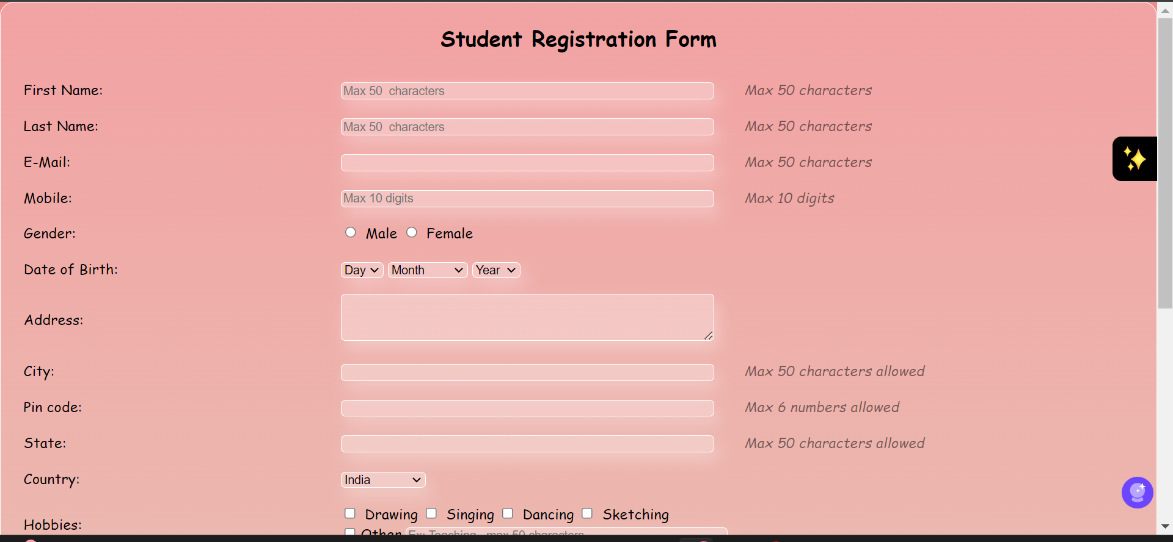

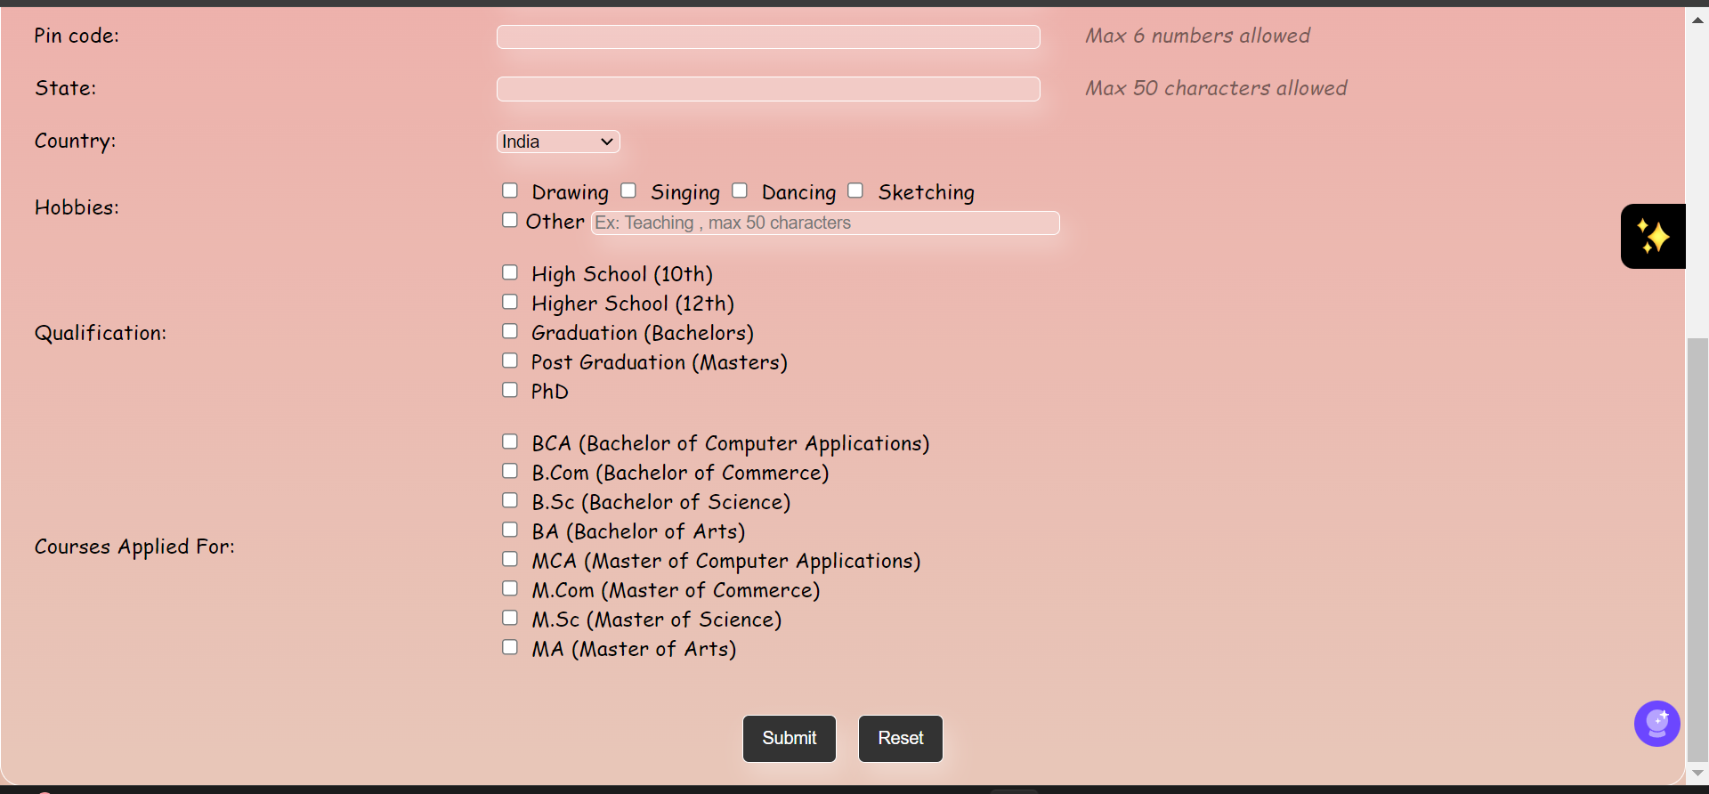

Objective-4-

Linking multiple Webpages together. One page must open the table created in  
the previous assignment. Second task is to insert an image which has some element, on  
clicking over those elements their description should open in new webpage.

Objective 5-Working with HTML div and ID. On the existing Webpage, create multiple  
divisions and classes. Apply CSS Box Model over the same. Implementing CSS IDs,  
classes and CSS Styling over the lists and tables.

Code for objective-4 and objective 5 ->

<!DOCTYPE html>

<html lang="en">

<head>

    <meta charset="UTF-8">

    <meta name="viewport" content="width=device-width, initial-scale=1.0">

    <title>Welcome to my page</title>

    <link rel="icon" href="pi.png">

    <style>

        *{

            padding: 0;

            margin: 0;

        }

        body{

           background-color: black;

        }

        .container{

            background-image: url(dark-background.jpg);

            height: 70vh;

        }

        .header{

            display: grid;

            grid-template-columns: repeat(2,1fr);

            align-items: center;

        }

        table{

            width: 100vw;

            border: 2px solid white;

        }

        #options{

            display: flex;

            align-items: center;

            justify-content:end;

        }

        .option{

            color:white;

            font-family: cursive;

            margin: 0.5vw;

            padding: 5px;

        }

        .option:hover{

            border-radius: 0.5rem;

            background-color: rgb(228, 89, 39);

            color: black;

        }

        #name{

            font-size: larger;

            color:white;

            font-family: cursive;

            margin-left:1vw;

        }

        .intro{

            color: white;

            width: 50vw;

            padding: 1rem;

        }

        #basic{

            font-family: cursive;

            padding: 1rem;

        }

        .imgContainer{

            border: 2px solid white;

            display: flex;

            flex-direction: column;

            padding: 1vw;

        }

      #image_text{

        margin: 1vw;

        color: white;

      }

      #img_heading{

        color: white;

      }

    </style>

</head>

<body>

    <div class="container">

    <div class="header">

       <p id="name">Halo !</p>

        <div id="options">

            <a href="portfolio2.html" id="portfolio" class="option">PORTFOLIO</a>

            <a href="table.html" class="option">TABLE</a>

            <a href="form.html" class="option">FORM</a>

          </div>

    </div>

    <div class="intro">

        <h1>I'm <i>Shashank,</i></h1>

        <br>

        <p id="basic">An engineering student, working hard towards learning new things, game enthusiasts even though I've never played much games. Currently learning React.JS.

            I'm an interested person finding it actually interesting to know how things are getting done. Competitor mentality, 💀Atleast tell me that whether it is a skull or a cute panda with opened mouth!!</p>

    </div>

    </div>

    <div class="imgContainer">

        <div id="img_heading"><h1>This is a clickable image</h1>For my interest in music, I created an image with various clickable tags that will guide you to the biography of some of the most famous musicians in India, have a good experience and tell me whether you liked the page or not...<h3>A small brief is presente here along with <b>the clickable image</b>:</h3></div>

       <img src="resized_musiciansd.jpg" alt="musicians" usemap="#music" style="width: 429px;">

       <map name="music">

        <area shape="rect" target="_blank"  coords="0,0,70,316" href="https://en.wikipedia.org/wiki/Hariprasad_Chaurasia" alt="" >

        <area shape="rect" target="_blank" coords="72,0,142,319" href="https://en.wikipedia.org/wiki/Zakir_Hussain_(musician)" alt="">

        <area shape="rect" target="_blank" coords="144,0,215,319" href="https://en.wikipedia.org/wiki/L._Subramaniam" alt="">

        <area shape="rect" target="_blank" coords="215,0,286,319" href="https://en.wikipedia.org/wiki/Ravi_Shankar" alt="">

        <area shape="rect" target="_blank" coords="286,0,361,319" href="https://en.wikipedia.org/wiki/Bismillah_Khan" alt="">

        <area shape="rect" target="_blank" coords="361,0,431,319" href="https://en.wikipedia.org/wiki/Bhimsen_Joshi" alt="">

       </map>

       <div id="image_text"> <br>

        <b>Pandit Ravi Shankar</b>: A legendary sitar virtuoso, Ravi Shankar was instrumental in popularizing Indian classical music globally. He collaborated with Western musicians such as George Harrison of The Beatles and composed music for various films. Shankar was a key figure in introducing the sitar to international audiences and was deeply influential in the world of music.

        <br><br>

        <b>Ustad Zakir Hussain</b>: A world-renowned tabla maestro, Zakir Hussain is celebrated for his extraordinary skill and versatility in both classical and fusion music. The son of Ustad Alla Rakha, he has performed with prominent musicians from around the world and contributed to blending Indian classical music with other global genres.

        <br><br>

        <b>Pandit Bhimsen Joshi</b>: An iconic vocalist of Hindustani classical music, Bhimsen Joshi was known for his deep, soulful renditions in the Kirana gharana tradition. His powerful voice and emotive style made him one of the most revered classical singers in India. He was also awarded the Bharat Ratna, India’s highest civilian honor.

        <br><br>

        <b>Ustad Bismillah Khan</b>: A maestro of the shehnai, Ustad Bismillah Khan was instrumental in elevating this instrument to the concert stage. He is synonymous with the sound of Indian classical music, particularly with Varanasi, his home city. He was awarded the Bharat Ratna for his contributions to music.

        <br><br>

       <b>Pandit Hariprasad Chaurasia</b>: A legendary bansuri (bamboo flute) player, Hariprasad Chaurasia is known for his mastery of the Hindustani classical tradition. He has also collaborated with artists from various genres and has been a key figure in bringing the flute to prominence in Indian classical music.

        <br><br>

        <b>Dr. L. Subramaniam</b>: A renowned violinist and composer, Dr. L. Subramaniam is celebrated for his proficiency in both Carnatic and Western classical music. He has performed with numerous international orchestras and is known for his fusion work, blending traditional Indian and Western classical music.

        <br><br>

        These artists are pillars of Indian classical music, each contributing uniquely to its rich heritage.

                                                                                                                                               </div>

    </div>

</body>

</html>

-----------------------------------------------------output------------------------------------------------------------------

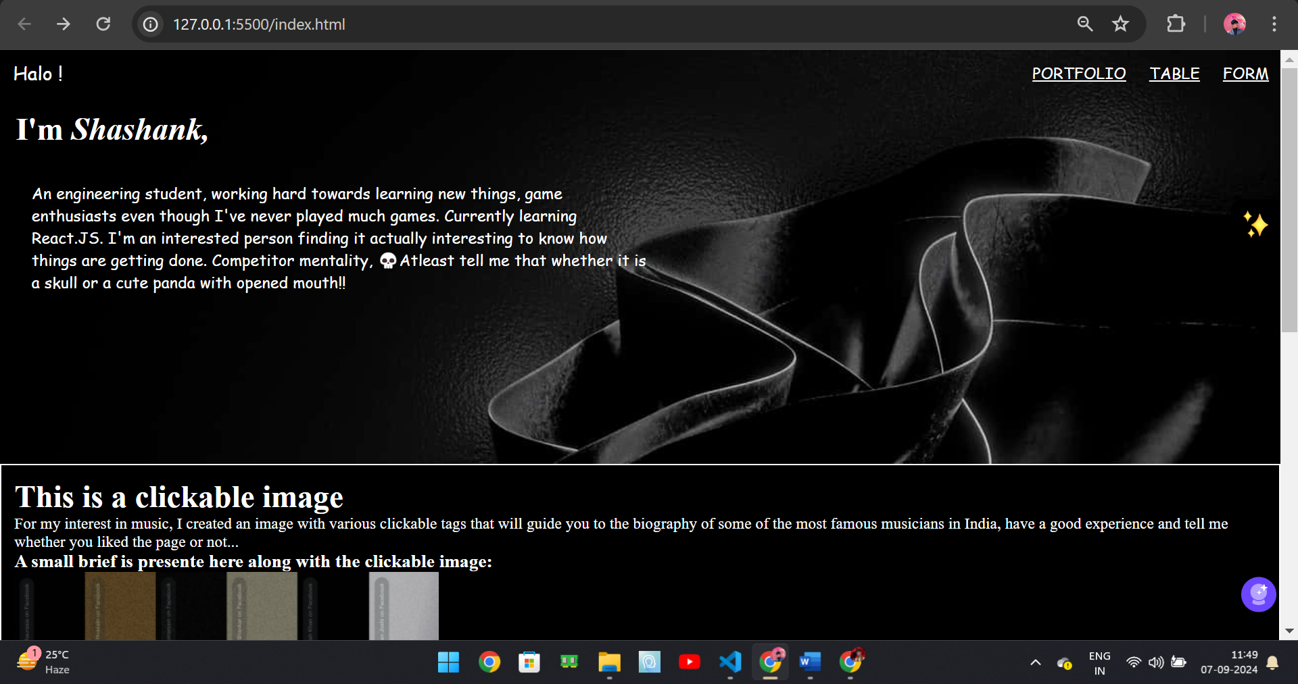

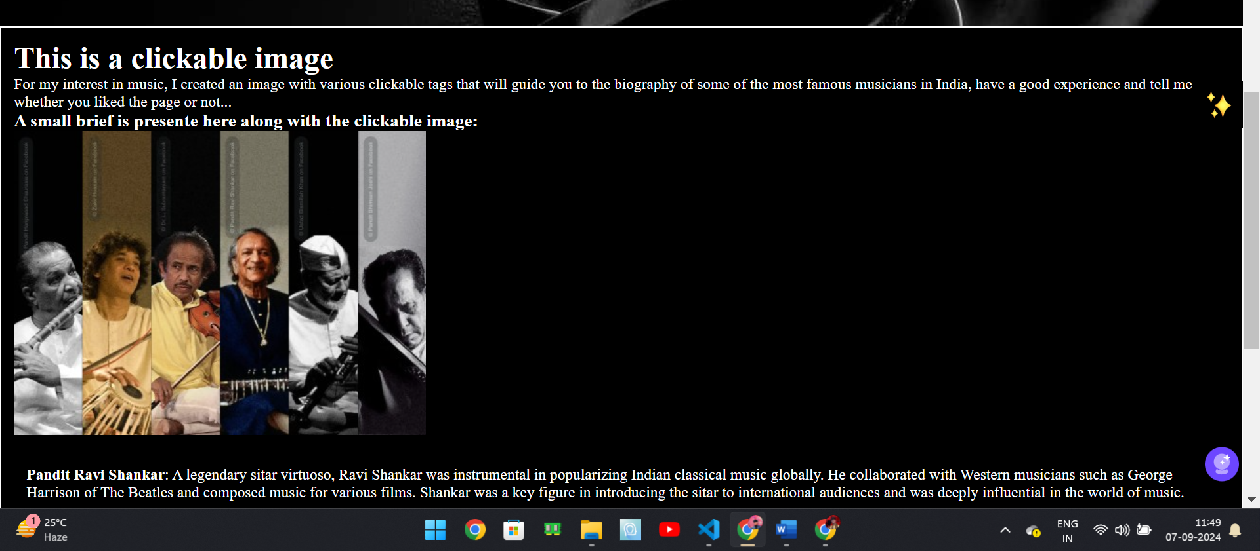

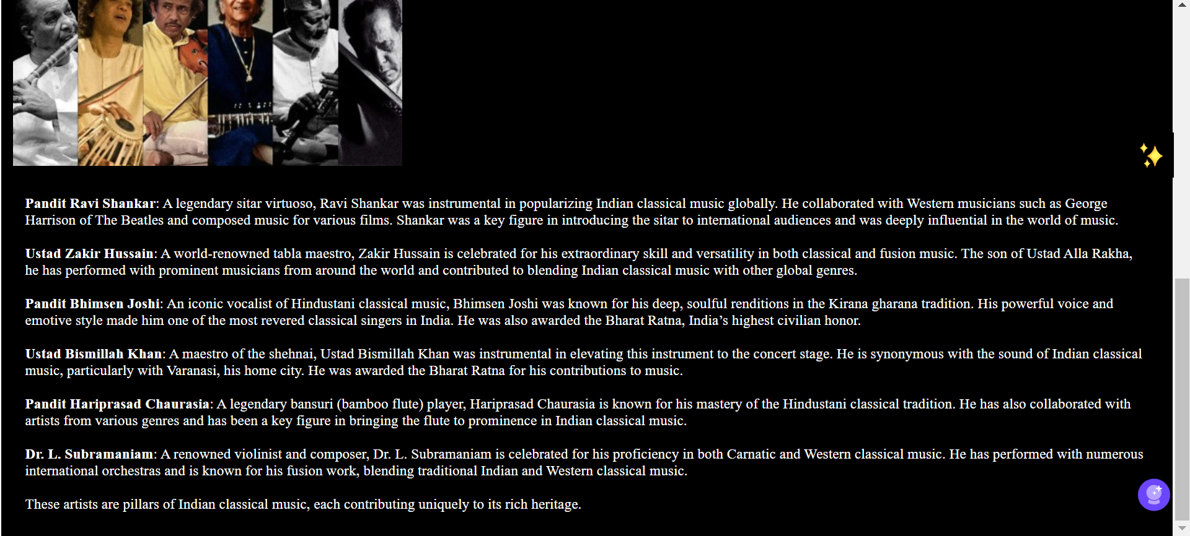

Objective-6-Design question paper of ten questions of yourself using CSS styling  
(background, text format, fonts) and some CSS colours. Assume a proper format for the  
question paper. Inline and Embedded.

Html code-

<!DOCTYPE html>

<html lang="en">

<head>

    <meta charset="UTF-8">

    <meta name="viewport" content="width=device-width, initial-scale=1.0">

    <title>Demon Slayer</title>

    <link rel="stylesheet" href="style.css">

</head>

<body>

    <form >

        <div class="intro">

            <div class="welcome"><h1>Welcome ! !</h1><h5>If you are a true Demon Slayer fan, consicer this as your test</h5></div>

        </div>

        <div class="basicQ">

            <p id="question">1. Who is the main protagonist of Demon Slayer?</p>

            <input type="radio" id="q1a" name="question1" value="a" onclick="toggleRadio(this)">

            <label for="q1a">a: Inosuke Hashibira</label><br>

            <input type="radio" id="q1b" name="question1" value="b" onclick="toggleRadio(this)">

            <label for="q1b">b: Zenitsu Agatsuma</label><br>

            <input type="radio" id="q1c" name="question1" value="c" onclick="toggleRadio(this)">

            <label for="q1c">c: Tanjiro Kamado</label><br>

            <input type="radio" id="q1d" name="question1" value="d" onclick="toggleRadio(this)">

            <label for="q1d">d: Kyojuro Rengoku</label><br><br>

            <p  id="question">2. What is the name of Tanjiro's sister who becomes a demon?</p>

            <input type="radio" id="q2a" name="question2" value="a" onclick="toggleRadio(this)">

            <label for="q2a">a: Nezuko Kamado</label><br>

            <input type="radio" id="q2b" name="question2" value="b" onclick="toggleRadio(this)">

            <label for="q2b">b: Shinobu Kocho</label><br>

            <input type="radio" id="q2c" name="question2" value="c" onclick="toggleRadio(this)">

            <label for="q2c">c: Mitsuri Kanroji</label><br>

            <input type="radio" id="q2d" name="question2" value="d" onclick="toggleRadio(this)">

            <label for="q2d">d: Kanao Tsuyuri</label><br><br>

            <p  id="question">3. Which breathing style does Tanjiro initially learn?</p>

            <input type="radio" id="q3a" name="question3" value="a" onclick="toggleRadio(this)">

            <label for="q3a">a: Flame Breathing</label><br>

            <input type="radio" id="q3b" name="question3" value="b" onclick="toggleRadio(this)">

            <label for="q3b">b: Water Breathing</label><br>

            <input type="radio" id="q3c" name="question3" value="c" onclick="toggleRadio(this)">

            <label for="q3c">c: Wind Breathing</label><br>

            <input type="radio" id="q3d" name="question3" value="d" onclick="toggleRadio(this)">

            <label for="q3d">d: Beast Breathing</label><br><br>

        </div>

        <div class="slayerQ">

            <p  id="question">4. Who is the Flame Hashira?</p>

            <input type="radio" id="q1a" name="question1" value="a" onclick="toggleRadio(this)">

            <label for="q1a">a: Giyu Tomioka</label><br>

            <input type="radio" id="q1b" name="question1" value="b" onclick="toggleRadio(this)">

            <label for="q1b">b: Kyojuro Rengoku</label><br>

            <input type="radio" id="q1c" name="question1" value="c" onclick="toggleRadio(this)">

            <label for="q1c">c: Sanemi Shinazugawa</label><br>

            <input type="radio" id="q1d" name="question1" value="d" onclick="toggleRadio(this)">

            <label for="q1d">d: Tengen Uzui</label><br><br>

            <p  id="question">5. Who is the Water Hashira?</p>

            <input type="radio" id="q2a" name="question2" value="a" onclick="toggleRadio(this)">

            <label for="q2a">a: Muichiro Tokito</label><br>

            <input type="radio" id="q2b" name="question2" value="b" onclick="toggleRadio(this)">

            <label for="q2b">b: Giyu Tomioka</label><br>

            <input type="radio" id="q2c" name="question2" value="c" onclick="toggleRadio(this)">

            <label for="q2c">c: Mitsuri Kanroji</label><br>

            <input type="radio" id="q2d" name="question2" value="d" onclick="toggleRadio(this)">

            <label for="q2d">d: Obanai Iguro</label><br><br>

            <p  id="question">6. Which Hashira uses the Sound Breathing technique?</p>

            <input type="radio" id="q3a" name="question3" value="a" onclick="toggleRadio(this)">

            <label for="q3a">a: Tengen Uzui</label><br>

            <input type="radio" id="q3b" name="question3" value="b" onclick="toggleRadio(this)">

            <label for="q3b">b: Shinobu Kocho</label><br>

            <input type="radio" id="q3c" name="question3" value="c" onclick="toggleRadio(this)">

            <label for="q3c">c: Sanemi Shinazugawa</label><br>

            <input type="radio" id="q3d" name="question3" value="d" onclick="toggleRadio(this)">

            <label for="q3d">d: Muichiro Tokito</label><br><br>

        </div>

        <div class="demonQ">

            <p  id="question">7. Who is the main antagonist and leader of the demons?</p>

            <input type="radio" id="q1a" name="question1" value="a" onclick="toggleRadio(this)">

            <label for="q1a">a: Muzan Kibutsuji</label><br>

            <input type="radio" id="q1b" name="question1" value="b" onclick="toggleRadio(this)">

            <label for="q1b">b: Akaza</label><br>

            <input type="radio" id="q1c" name="question1" value="c" onclick="toggleRadio(this)">

            <label for="q1c">c: Daki</label><br>

            <input type="radio" id="q1d" name="question1" value="d" onclick="toggleRadio(this)">

            <label for="q1d">d: Enmu</label><br><br>

            <p  id="question">8. Which demon was responsible for the Mugen Train incident?</p>

            <input type="radio" id="q2a" name="question2" value="a" onclick="toggleRadio(this)">

            <label for="q2a">a: Gyutaro</label><br>

            <input type="radio" id="q2b" name="question2" value="b" onclick="toggleRadio(this)">

            <label for="q2b">b: Enmu</label><br>

            <input type="radio" id="q2c" name="question2" value="c" onclick="toggleRadio(this)">

            <label for="q2c">c: Gyokko</label><br>

            <input type="radio" id="q2d" name="question2" value="d" onclick="toggleRadio(this)">

            <label for="q2d">d: Kaigaku</label><br><br>

            <p  id="question">9. Who is the Upper Moon Three demon?</p>

            <input type="radio" id="q9a" name="question3" value="a" onclick="toggleRadio(this)">

            <label for="q3a">a: Akaza</label><br>

            <input type="radio" id="q9b" name="question3" value="b" onclick="toggleRadio(this)">

            <label for="q3b">b: Kokushibo</label><br>

            <input type="radio" id="q9c" name="question3" value="c" onclick="toggleRadio(this)">

            <label for="q3c">c: Doma</label><br>

            <input type="radio" id="q9d" name="question3" value="d" onclick="toggleRadio(this)">

            <label for="q3d">d: Rui</label><br><br>

        </div>

        <div class="rengokuQ">

            <p  id="question">10. Which Upper Moon demon was responsible for Rengoku's death?</p>

        <input type="radio" id="q10a" name="question1" value="a" onclick="toggleRadio(this)">

        <label for="q1a">a: Doma</label><br>

        <input type="radio" id="q10b" name="question1" value="b" onclick="toggleRadio(this)">

        <label for="q1b">b: Akaza</label><br>

        <input type="radio" id="q10c" name="question1" value="c" onclick="toggleRadio(this)">

        <label for="q1c">c: Kokushibo</label><br>

        <input type="radio" id="q10d" name="question1" value="d" onclick="toggleRadio(this)">

        <label for="q1d">d: Gyutaro</label><br><br>

        <p  id="question">11. During which arc does Rengoku die?</p>

        <input type="radio" id="q11a" name="question2" value="a" onclick="toggleRadio(this)">

        <label for="q2a">a: Mugen Train Arc</label><br>

        <input type="radio" id="q11b" name="question2" value="b" onclick="toggleRadio(this)">

        <label for="q2b">b: Entertainment District Arc</label><br>

        <input type="radio" id="q11c" name="question2" value="c" onclick="toggleRadio(this)">

        <label for="q2c">c: Final Battle Arc</label><br>

        <input type="radio" id="q11d" name="question2" value="d" onclick="toggleRadio(this)">

        <label for="q2d">d: Infinity Castle Arc</label><br><br>

        <p  id="question">12. What were Rengoku's last words to Tanjiro?</p>

        <input type="radio" id="q12a" value="a" onclick="toggleRadio(this)">

        <label for="q3a">a: "Never give up, no matter what."</label><br>

        <input type="radio" id="q12b"  value="b" onclick="toggleRadio(this)">

        <label for="q3b">b: "Take care of my family."</label><br>

        <input type="radio" id="q12c" value="c" onclick="toggleRadio(this)">

        <label for="q3c">c: "Set your heart ablaze."</label><br>

        <input type="radio" id="q12d"  value="d" onclick="toggleRadio(this)">

        <label for="q3d">d: "You are the future of the Demon Slayer Corps."</label><br><br>

        </div>

       <div class="BTN">

       <button type="submit">SUBMIT</button>

        <button type="reset">RESET</button>

       </div>

    </form>

</body>

</html>

CSS code

*{

    padding: 0;

    margin: 0;

    justify-content: center;

}

body{

    font-size: 150%;

}

.intro{

   background-image: url(src/kidf.jpg);

    background-size: cover;

    background-position: center;

    background-repeat: no-repeat;

    background-attachment:fixed;

    height: 100vh;

    display: flex;

    font-size: 150%;

    justify-content: center;

    align-items: center;

    text-align: center;

}

#question{

 font-family: 'Lucida Sans', 'Lucida Sans Regular', 'Lucida Grande', 'Lucida Sans Unicode', Geneva, Verdana, sans-serif;

}

.basicQ{

    background: url(src/yoir.jpg);

    padding: 1vw;

    background-size: cover;

    background-position: center;

    background-repeat: no-repeat;

    background-attachment:fixed;

    height: 100vh;

}

.slayerQ{

 background-image: url(src/slayer2.jpg);

 padding: 1vw;

 background-size: cover;

    background-position: center;

    background-repeat: no-repeat;

    background-attachment:fixed;

    height: 100vh;

}

.demonQ{

    background: url(src/demon2.jpg);

    padding: 1vw;

    background-size: cover;

    background-position:center;

    background-repeat: no-repeat;

    background-attachment:fixed;

    height: 100vh;

}

.BTN{

    display: flex;

    background-color: black;

    align-items: center;

    padding: 1vw;

}

button{

   margin: 1vh;

}

.rengokuQ{

    padding: 1vw;

    background: url(src/renDied.png);

    background-size: cover;

    background-position: center;

    background-repeat: no-repeat;

    background-attachment:fixed;

    height: 100vh;

}

